**Hardik Arora**

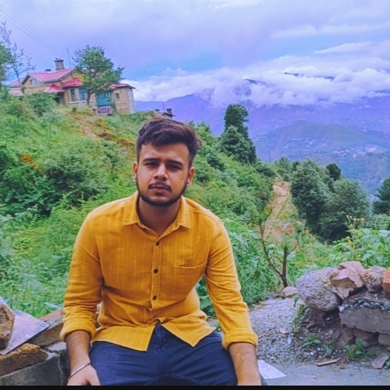

Agra, +91 9997859116, [hardik.arora_cs.aiml@gla.ac.in](mailto:hardik.arora_cs.aiml@gla.ac.in)

LinkedIn: <https://www.linkedin.com/in/hardik-arora-a34143298> Github: https://github.com/hardik121121

# EDUCATION

**Bachelor of Technology in Computer Science, *GLA University, Mathura, 76.2%*** Sep 2024

**Intermediate, Baluni Public School, Agra, *82.8%.*** May 2022

**High School, St. Peter’s College, Agra, *78.6%*** May 2020

# INTERNSHIP/ TRAINING EXPERIENCE __________________________________________________________________

**Cognifyz Technologies Remote, (Virtual Internship)** Dec 2023 – Jan 2024

*Java Developer Intern*

* Developed a password validation algorithm to assess strength using length, character variety, and pattern recognition. .
* Developed a cryptographic algorithm to securely encrypt and decrypt files, ensuring data confidentiality.

**Accenture, Remote, (Virtual Internship)** May 2024 – June 2024

*Data Analytics and Visualization Intern*

* Analyzed and cleaned datasets to identify the top 5 most popular content categories for Social Buzz.
* Created visualizations and presented insights to the client through a PowerPoint presentation.

**Job Oriented Value Added Course, GLA University, Mathura** June 2024 – July 2024

*Trainee*

* Learnt basics of HTML, CSS and Java Script, React, MongoDB, Express.js, Node.js.
* Post completing the training, created a Project named “Quizify-Quiz-App”, by using Frontend and Backend technologies.

# PROJECTS

**Quizify - Quiz WebApp** [https://github.com/hardik121121/JOVAC_FullStack_Project2024_Quizfy](https://github.com/hardik121121/JOVAC_FullStack_Project2024_Quizfy%20%20%20%20%20%20%20%20%20%20%20%20%20%20%20%20%20%20%20%20) June 2024 – July 2024

* Created a dynamic quiz application using the MERN stack with features like timers and score tracking.
* Designed a responsive UI with React, CSS, and Bootstrap, and implemented backend with Node.js and MongoDB.

**Encryption/Decryption Tool** https://github.com/hardik121121/Encryption-Decryption-Tool Mar2024 – Apr 2024

* Used AES techniques to develop an encryption/decryption tool using Python where both sender and receiver use a shared key for encrypting and decrypting text.
* Technologies used: Python, Tkinter, Cryptography, AES (Advanced Encryption Standards).

**Movie Rating Predictions** https://github.com/hardik121121/Miniproject-2nd-Year---Sentimental-Analysis-on-Movie-Rating-Predictions-using-LSTM Mar2024 – Apr 2024

* As a team we developed a LSTM-based sentiment analysis model for movie rating prediction. Achieved 85% accuracy on IMDB dataset.
* Technologies used: Python, Pandas, Numpy, NLTK, Scikit Learn, TensorFlow, Keras.

# SKILLS

**Technical Professional**

Java, React Problem-Solving

Python, Apex Effective Communication Skills

MYSQL Adaptability

# PROFESSIONAL ACHIEVEMENTS

* Secured 3rd place in the Technical Paper Presentation at IBM ICE DAY 2024 for the topic 'Voice Alchemy: AI-Crafted Voices for Fun and Function'..
* Certified for completing the Microsoft AI Odyssey Challenge by developing NLP solutions using Azure AI.
* Earned Store Listing Certificate from Google Play Academy for crafting compelling app descriptions and global marketing.
* Qualified for Smart India Hackathon 2023, contributing to a project on human target detection.

# CO-CURRICULAR ACTIVITIES

* Coordinated SRIJAN (Cultural Fest, GLA, September, 2023).
* Volunteered in AAGAZ (Alumni Meet, GLA, October, 2022).

**DECLARATION________________________________________________________________________________________**

I hereby declare that all the above mentioned information is true and correct to the best of my knowledge.